# **What is Heart Rate Variability (HRV)?**

Your heart does not beat in a perfectly regular rhythm as would a metronome. The variation in time between consecutive heartbeats is referred to as heart rate variability (HRV). Beat-to-beat variations in your heart rate are healthy and normal. To understand more about how Garmin® and Firstbeat Analytics™ use heart rate variability to give you better information about the state of your body, start with why heart rate variability exists.

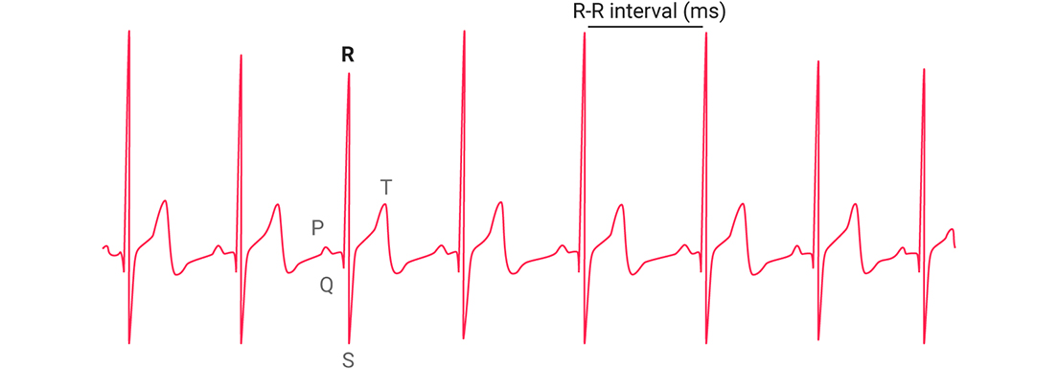

## **How Does Your Body Manage Your HRV?**

Your heart is controlled by your autonomic nervous system (ANS), which is the involuntary part of your nervous system. There are two branches of the ANS: the sympathetic and the parasympathetic. The sympathetic branch of your ANS is active when you are under some kind of stress. It is the part of your ANS that puts all systems on alert. By contrast, the parasympathetic branch is the more relaxed part that just hums along when you are relaxed. When the sympathetic branch is more active, your heart rate typically increases, and it beats in a more regular rhythm — meaning HRV decreases.

On the other hand, when the parasympathetic branch is more active, your heart rate decreases. Your heart will beat to meet the body’s needs, but not on such a strict schedule as when the sympathetic branch is in charge. In other words, HRV increases. Because of these characteristics, HRV is a great indicator of the balance between the activity of the two branches of the autonomic nervous system. Therefore, it is an indirect measurement of stress. Higher HRV means lower stress.

Source: https://support.garmin.com/en-GB/?faq=04pnPSBTYSAYL9FylZoUl5